
College of Engineering and Physical Sciences
School of Informatics & Digital Engineering, Computer Science
Final Report or Term Report
Title: add a few words that informs the reader of something important
Author
E-mail: 230093849@aston.ac.uk
Supervisor: Dr Aniko Ekart
April 2026
Abstract
Algorithmic bias in machine learning presents important issues within the employment, criminal justice, and healthcare sectors. Although technical solutions exist for identifying and reducing bias, they typically require users to have programming knowledge, which many decision-makers lack. As a result, most users of artificial intelligence systems are unable to independently assess fairness due to the systems' inaccessibility. The FairChecker online tool addresses this gap by allowing people to identify prejudice without coding. The FairChecker tool trains a Decision Tree classifier on any uploaded CSV file, evaluates three known fairness metrics (Demographic Parity Gap, Equal Opportunity Gap, and Equalised Odds Gap), and finally shows findings in plain English and visually through bar charts, including a comparison using a reweighing approach. After tests were completed on three standard datasets, including adult income, criminal justice, and healthcare, FairChecker revealed bias patterns consistent with earlier research, such as racial discrimination in the COMPAS recidivism system. The project also identifies its limitations and makes valuable suggestions for future improvements.

Keywords: topic1, topic2, topic3, topic4, topic5.

List of Acronyms
TCP/IP Transfer Control Protocol/Internet Protocol
RAM Random Access Memory

Dedication | Acknowledgements | Preface (each optional – choose one)
I dedicate this work.

(remove this if Acknowledgements or Preface)
List your acknowledgements here (except for partial Term Reporting – save it for the final version).
Create single pages for each type you want to add (either dedication, acknowledgements, or preface).

Table of Contents
1 Introduction 8
1.1 Motivation 9
1.2 Organisation 9
2 Related work 10
2.1 Bias In Machine Learning 10
2.2 Fiarness Metrics 10
2.3 Bias Mitigation Techniques 11
2.4 Existing Bias Detection Tools 12
2.5 Research Gap 13
3 Methodology and Design 14
3.1 Project Management Methodology 14
3.2 Requirements Specification 15
3.3 System Architecture !!!! 18
3.4 Technology Choices 20
3.5 Dataset Selection 21
3.6 Implementation 22
3.7 Ethical Considerations 24
4 Evaluation and Results 26
4.1 Evaluation Methodology 26
4.2 Adult Income Dataset Results 27
4.3 COMPAS Recidivism Dataset Results 28
4.4 Heart Disease Dataset Results 30
4.5 Cross-Data Comparison and Mitigation Analysis 32
4.6 Critical Reflection 33
5 Conclusion, Limitations and Future Work 42
5.1 Conclusion 42
5.2 Limitations 43
5.3 Future Work 43
6 References 45
7 Appendices 46
7.1 Appendix 1: SDLC details 46
7.2 Appendix 2: Code 46
7.3 Appendix 3: Meetings with supervisor 46

(after updating the table of contents, re-apply Style “Table of Contents – items”) – remove this
List of Figures
Figure 1: A panda sleeping. This is called the ‘caption’ of a figure. Error! Bookmark not defined.

Introduction

Decisions such as job application rejections, reoffending risk assessments and bank loan denials often appear definitive and impartial, however it is frequently unclear wheather the process was fair or if a machine learning algorithm affected these results. Artificial systems are increasingly used in areas with elevated risks such as recruiting, healthcare, credit scoring and criminal justice which significantly impact individuals’ lives. Although the systems used are considered neutral and reliable, their performance is dependent on the data used for training. Historical data is commonly used to train data, which often reflects social inequalities; as a result, machine learning models can imitate and reinforce these biased patterns and result in unfair outcomes for specific demographic groups.

This issue has legitimate real-world consequences that affect society at both the individual and organisational levels. For example, Amazon's internal recruitment tool was found to disadvantage female candidates by imitating male-dominated hiring patterns, which was discontinued after this bias was detected (Dastin, 2018). Additionally, the COMPAS recidivism tool applied in the criminal justice system in the United States, was found to produce nearly twice as many false positive rates for Black defendants as it did for white defendants (Angwin et al. 2016), clearly highlighting the racial bias within credible systems which may have lasting impacts on individuals’ lives. Both the mentioned cases demonstrate the persistent risk of bias in artificial intelligence in machine learning systems trained on existing social disparities.

Although tools to detect and correct algorithmic bias are available, their use in everyday life is very limited. To assess differences across demographic groups, researchers have developed fairness metrics such as demographic parity, equal opportunity and equalised odds. Frameworks such as IBM’s AI Fairness 360 provide strong detection and mitigation abilities (Bellamy et al., 2019), however these tools rely on programming skills and an understanding on maching learning pipelines, which non-technical users lack. As a result, HR experts responsible for hiring applications or bank managers determining loan acceptances, are unable to assess fairness using these technical tools. This leads to fairness evaluations that are typically insufficient or overlooked, even when advanced techniques are available. Ferrara et al. discovered in a survey of 117 industry professionals, that fairness is often ignored through system development, compared to accuracy and security which are prioritised (Ferrara et al. 2023). This is usually due to the significant gap between technical ability and practical application, rather than a lack of organisational concern.

This project addresses the gap mentioned, by delivering a web-based bias detection tool accessible for non-technical users. It allows users to upload a CSV dataset or select a popular sets already available, then the user can select the outcome and sensitive attribute of interest. The tool internally trains a decision tree classifier, generates predictions and analyses fairness metrics, displaying the findings simply and clearly with visualisations. The tool also includes a comparison of before and after mitigation techniques are applied, demonstrating the changes in fairness when reweighing is used, making the trade-offs between fairness and performance clear. The evaluation uses three real-world datasets: UCI Adult Income, COMPAS Recidivism, German Credit, and Heart Disease. The EU AI Act (2024) requires bias auditing for highly risky systems in credit scoring, recruitment and criminal justice, which consequently makes easily accessible fairness tools a legal requirement.

Motivation
Studying computer science involves not only the development of systems, but also a detailed evaluation of their weaknesses. For example, a hiring tool that denies qualified applicants does not leave a documented explanation for their rejection, and a credit scoring model that unfairly rejects applications does not reveal its discriminatory behaviour. Unfortunately, this harm tends to remain unnoticed by both affected individuals and organisations involved. This project is based on the idea that revealing bias within systems is key to correcting them for the future. Rather than creating new fairness metrics or algorithms, the project uses current fairness techniques and focuses on enhancing their usability for professionals who use AI systems in real-world settings, regardless of their technical abilities.

Organisation
The remaining sections of this report are structured as follows. Section 2 reviews related research on algorithmic bias, fairness metrics, and current tools while outlining key findings which influenced design decisions for this project. Section 3 discusses the design of the tool and performance, detailing its architecture, model selection and dataset choices. Section 4 displays and analyses the evaluation findings from all datasets, and finally, Section 5 summarises the results, limitations and recommendations for future research. !!!!!!!!!!!!!!!

Related work
This section reviews the literature, which was used in the design and development of this project’s bias detection tool. Key research findings are discussed, as they influenced decisions such as the datasets selected, fairness metrics and the prioritisation of usability.

Bias In Machine Learning
Algorithmic bias is an issue which can appear at any stage of the machine learning process, which is why continuous prevention techniques should be applied as early as possible. According to research, bias can be caused by historical bias in training data, sampling bias from unrepresentative datasets or bias introduced during optimisation processes (Mehrabi et al., 2021). Some researchers argue that bias actually emerges during initial stages, including data collection, feature selection, and model implementation, instead of a particular point. Considering this concept, this project measures the fairness of the model's results across demographic groups, rather than focusing on bias at a single stage.
Proxy variables present challenging obstacles in algorithmic fairness. The removal of sensitive attributes such as race, gender or age fails to prevent discrimination, due to related features still possibly storing this information and resulting in biased outcomes in models that appear fair (Barocas and Selbst, 2016). This impact is known as the disparate effect, which demonstrates that simply removing protected attributes does not eliminate the risk of bias. Therefore, the project's tool includes the sensitive attribute in its analysis, to ensure fairness is directly measured rather than assuming it by removing certain details.

Real-life examples highlight the negative impacts of algorithmic bias, as mentioned in cases in section 1. Both the Adult Income and COMPAS datasets were carefully selected to evaluate this project because their documented patterns are readily available in the literature. The tool’s findings will be compared against these established results to determine the effectiveness and accuracy of the tool.

Fiarness Metrics

The concept of fairness in machine learning varies according to its definition, as the fairness metrics selected impact how bias is identified and understood. This demonstrates how the selection of fairness metrics is a strategic decision with legal and organisational implications, not only technical (Pessach and Shmueli, 2022). Understanding these options influences the choice of metrics used for this project.

The tool uses three key fairness metrics, including Demographic parity, which measures if the model assigns positive predictions for different groups at the same rate. This measure was used due to its accessibility to non-technical users, and is also consistent with legal standards, such as the 80% rule in employment and credit regulation (Pessach and Shmueli, 2022). Another metric used was Equal opportunity, which involves testing whether the model finds individuals who get favourable outcomes equally across groups (Hardt et al., 2016). This is particularly important within hiring and loan approvals, as eligible individuals from minority groups are overlooked, creating serious long-term harm. Finally, Equalised odds were used to ensure that both the identification of eligible people and the distribution of model mistakes are balanced across groups (Hardt et al., 2016).

All three metrics are incorporated due to their mathematical incompatibility. It is usually impossible to meet all three criteria simultaneously when base rates between groups differ (Chouldechova, 2017). The COMPAS example demonstrates this issue, as the system achieved predictive parity across racial groups while violating equalised odds, resulting in nearly double the false positive rates for Black defendants as for white defendants (Angwin et al., 2016). This shows how model may meet one metric, yet still cause considerable harm, such as misleading stakeholders by reporting only one metric. Therefore, providing all three metrics offers a deeper and more accurate evaluation of the system’s fairness.

The literature reviewed reveals that selecting a fairness metric carries major legal and financial consequences, as different fairness constraints produce different costs. For example, in credit scoring, certain fairness standards affect profitability; it was found that independence-based constraints caused the greatest profit loss, compared to separation-based constraints aligned with equalised odds which offered the most sustainable balance (Kozodoi et al., 2022). This evidence reinforces the impact of fairness metric selections being both a technical and a business decision, with real-world consequences for organisations. This project provides a comparison of results before and after mitigation techniques are applied, illustrating these costs of metrics, to allow stakeholders to observe how reweighing affects each metric while evaluating the resulting drop in accuracy.

Bias Mitigation Techniques

After bias is detected, it is important to determine the most effective approach to address it. Researchers identify three main techniques for treating bias, including pre-processing, which makes changes to the training data before the model is developed. In-processing involves adding fairness standards during training, whereas post-processing modifies the model’s results after training is completed (Pessach and Shmueli, 2022). Each of the mentioned strategies has its own trade-offs, which should be considered before implementation.

!!!!!
Pre-processing was chosen for this project due to its compatibility with any classifiers and does not require access to the model’s underlying structure (Pessach and Shmueli, 2022). Specifically, a reweighing method will be used to adjust the influence of training data, by assigning sample weights to underrepresented groups, giving them greater influence without altering underlying datasets. This method was implemented using Scikit-learn’s ‘compute_sample_weight’ function where no external fairness libraries were needed. This ensures my project is accessible to non-technical users who may not have control over their model’s architecture and supports future versions of the tool, in which multiple model types can be used without altering the mitigation approach. Studies have confirmed the suggested trade-off, where reweighing DOUBLE CHECK PAPER IF THIS OR REWIGHING improves fairness metrics but slightly reduces accuracy (Bellamy et al., 2019). This trade-off is presented to users of the tool through a comparison of Model A and Model B, allowing them to assess both the improvement in accuracy and the associated accuracy cost.

In-processing techniques were not implemented since, unlike pre-processing, full access to the model’s architecture and training process is required, which is unavailable for black-box systems which display results without an explanation for how the decision was made internally (Pessach and Shmueli, 2022). Post-processing was also excluded due to its significant legal concerns (Bellamy et al., 2019), such as anti-discrimination laws, which may be broken when predictions are adjusted based on demographic groups.
Existing research reveals that no single technique can consistently deliver desired outcomes, as improving fairness within systems often sacrifices optimal accuracy or profit (Mehrabi et al., 2021; Kozodoi et al., 2022). Reweighing was selected due to its practical balance, compatibility with any model, ease of understanding, and, importantly, its transparency regarding its limitations, which is an essential aspect for tools intended for non-technical users. Bellamy et al. (2019) confirm that reweighing is one of the most well-established pre-processing mitigation techniques, having been implemented as a core feature of AIF360, which influenced its use within this tool.

Existing Bias Detection Tools
Due to the growing awareness of algorithmic bias, tools have been developed which allow organisations to identify and address unfair results within their own machine learning systems. For example, IBM’s AI Fairness 360 (AIF360) is a detection tool, which offers over seventy fairness metrics and bias analysis features throughout the machine learning process (Bellamy et al., 2019). This tool is one of the strongest and frequently used in academic research, along with this project, where it’s bias evaluation methods influenced several decisions including the implementation of reweighing to reduce bias and post-prediction fairness tests.

Tools such as Aequitas and Fairlean from the Microsoft tool kit, help audit model predictions across demographic groups. Similar to AIF360, they provide quantitative fairness metrics and technical documentation, allowing data scientists to identify differences and evaluate mitigation solutions. These tools help to translate fairness research into practise. However, these tools often assume users have advanced technical skills, which is rarely accurate. AIF360 and Aequitas require Python skills, along with familiarity with machine learning pipelines and statistical fairness, which can be an issue for users who control AI systems but are not specialised. A study of 117 industry professionals revealed that fairness is often disregarded during system development (Ferrara et al., 2023); this is likely due to the uneven distribution of required skills among teams. As a result, fairness checks are frequently neglected or assigned to a smaller group of technical experts.

This project addresses this gap by allowing advanced technology to be accessible to a wider population. Unlike AIF360 and similar systems, this tool does not require users to possess any programming experience or machine learning knowledge, making it accessible to all individuals. Users begin by uploading a dataset of their choice, or have the option to select an already available popular dataset, where they are able to specify columns for analysis and ultimately receive a clear fairness report shown as bar charts and simple, written English. This project does not intend to replace existing technical tools, but rather aim to make it more feasible for non-technical stakeholders to identify bias.

Research Gap

Research shows that despite the increasing availability of technical bias detection and mitigation tools, the development of tools that are accessible, user-friendly, and provide clear explanations remains limited. This matters because bias cannot be recognised at a particular moment; rather it can arise at different stages of the machine learning pipeline and cannot be represented by a single fairness metric (Mehrabi et al., 2021). Even when bias is identified, addressing it becomes an additional challenge organisations face, as reducing bias introduces unavoidable trade-offs between fairness and accuracy, which depend on the dataset or domain (Kozodoi et al., 2022). Although the tools designed to navigate this issue are technically advanced, they require expertise which most real-world decision-makers lack (Bellamy et al., 2019; Ferrara et al., 2023).

This project addresses the need for an extensive bias detection system usable by non-technical users by prioritising clarity and accessibility. Existing systems are quite complex, such as AIF360 and Aequitas, which require users to write code, configure machine learning pipelines and analyse statistical results on their own. This obstacle is not accidental, but rather due to these tools being developed by researchers for the use of other researchers (Bellamy et al., 2019). This is also challenging in an organisational aspect, as individuals responsible for implementing AI in crucial areas, such as HR managers and credit analysts, are often the least capable of evaluating the fairness of these systems, risking inaccurate, long-term decisions. Ferrara et al. (2023) identified this gap as a result of the lack of accessible tools rather than technical skills, as usability is not prioritised as much as technical issues within fairness research.

This project attempts to address prevalent gaps by presenting a tool that combines autonomous model training, simultaneous evaluation of three fairness metrics, clear results, and a final comparison of pre- and post-bias mitigation in the model. The tool is accessible through a web interface, which is designed considering users without prior programming experience, which is a feature most tools do not provide. Three real-world datasets were used to effectively evaluate the tool, including income prediction, criminal justice recidivism and healthcare; as previously mentioned, these sectors are especially vulnerable to biased algorithms.

Methodology and Design

Project Management Methodology

Two main methodologies were evaluated in order to select the appropriate development strategy for this project. Sequential models, including waterfall, require establishing requirements before development begins, whereas iterative models allow changes to be made throughout the process. Considering this comparison, an iterative model was chosen to effectively allow design decisions to change in response to new findings from the literature review.

A Waterfall approach has some strengths, including its sequential structure, which provides clear milestones, timelines and detailed documentation throughout different stages. As a result, this type of model is most applicable to large-scale development projects, as the requirements are established before development begins (Sommerville, 2016). However, Waterfall assumes that these requirements do not change after a phase is completed, which does not align with this project, as design decisions continuously changed as more literature was reviewed. During the development of this tool, it was found that simpler interface features were required to guarantee accessibility, therefore new elements such as the Plain English Summary and the Model A vs Model B reweighing comparison, which were not originally planned components, were developed through iterative testing. If the project had followed a Waterfall approach, these design changes would not have been able to be completed. This demonstrates that a Waterfall approach was not suitable for this project, where continuous research adjusts the project's requirements.

An Agile framework was found to be the most suitable for this project because the requirements did not need to be set before project development, allowing for changes to be made as the project progressed. In contrast to Waterfall, an Agile approach allows for regular reviews and improvements to be made, as development is divided into short and repeatable cycles (Beck et al., 2001). Each sprint within this project produced a working version of the tool, which allowed for continuous testing and improvements to be made. Although an Agile approach is the most suitable for this project, it also presents some obstacles which were considered; without the thorough planning of sprints, projects can lose their focus and result in scope creep, where the project gradually expands beyond control (Sommerville, 2016). To avoid this risk, a Trello board was used to manage tasks and track decisions across sprints. Furthermore, components of both Scrum and Kanban were combined and applied to this project’s development to ensure clarity and efficiency. The project incorporated Scrum’s time-limited sprints to ensure continuous progress and focus, along with the Trello board, which served as a Kanban system to allow priorities to be adjusted when necessary.

Development of the project was organised across six monthly phases from October 2025 to March 2026. In October, the project began with research being gathered on AI bias and fairness metrics, along with the evaluation of existing tools and planning of the project's methodology. After this was completed, the tool’s architecture and interface were designed, including the selection of which fairness metrics and datasets would be used. Research through literature was a consistent process throughout the project’s development, resulting in regular improvements being made, which would not have been possible under a sequential model. Implementation and testing of the tool ran through January onwards, along with usability findings helping with the final refinements before submission in April.

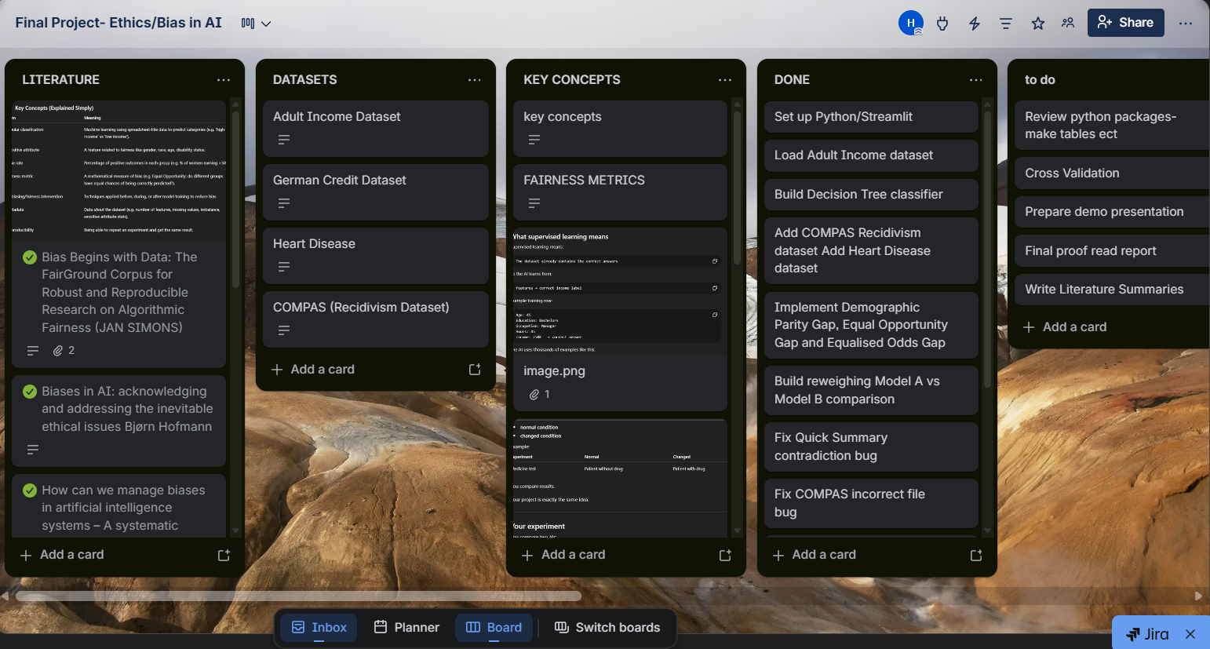
Figure 1:Trello board used to manage sprint tasks and design decisions as the project developed

The iterative structure of the project was effective in addressing sudden challenges which rose throughout the development process. For example, the ‘Quick Summary’ written section sometimes contradicted the numerical fairness metric outputs by finding a model fair, while the gap results suggested bias. However, this was identified and resolved within the same sprint, which allowed development to progress without errors or inaccurate findings. The COMPAS dataset also resulted in some challenges; the dataset produced random predictions due to an incorrect file being loaded and used to train the model. This issue was also able to be identified immediately due to the flexibility of the Agile approach.
Additionally, the decision was made to entirely remove the German Credit dataset from the tool after producing 100% classifier accuracy, and there was no difference before and after mitigation processes. After some research into the possible cause, it was suspected to be due to possible data leakage rather than model performance, which is documented in Section 5, as a challenge of this project. These issues demonstrate how Agile frameworks allow for issues to be identified and corrected iteratively and early within project development, rather than being discovered at the end (Beck et al., 2001).

Beck, K., Beedle, M., van Bennekum, A., et al. (2001) Manifesto for Agile Software Development. Available at: https://agilemanifesto.org (Accessed: 10 April 2025).
Chouldechova, A. (2017) 'Fair prediction with disparate impact: A study of bias in recidivism prediction instruments', Big Data, 5(2), pp. 153–163.
Sommerville, I. (2016) Software Engineering. 10th edn. Harlow: Pearson.

Requirements Specification

In a structured software project, it is important that requirements are clearly defined before and during development (Sommerville, 2016). Within this project, the requirements were developed iteratively as more literature was reviewed and early versions of the tool were tested. However, the core requirements were recognised early on, considering full accessibility to non-technical users, while also delivering reliable fairness analysis. As shown below, the requirements of the project are divided into functional, which represent what the tool must do, and non-functional, referring to how the tool should behave.

Table 1: Functional requirements
ID | Requirement | Justification
FR1 | Allow users to upload a CSV dataset | User accessibility needs
FR2 | Provide three preset dataset buttons: Adult Income, COMPAS, Heart Disease | User accessibility needs
FR3 | Auto-detect known datasets and pre-fill sensitive attribute dropdowns | User accessibility needs
FR4 | Automatically train a Decision Tree classifier on the uploaded data | User accessibility needs
FR5 | Calculate and display the Demographic Parity Gap | Mehrabi et al. (2021)
FR6 | Calculate and display the Equal Opportunity Gap | Hardt et al. (2016)
FR7 | Calculate and display Equalised Odds Gap | Hardt et al. (2016)
FR8 | Display a Plain English Quick Summary verdict | Ferrara et al. (2023)
FR9 | Compare Model A (original) vs Model B (oversampled) fairness metrics | Bellamy et al. (2019)
FR10 | Generate random sample profiles for prediction | User accessibility needs
FR11 | Display a prediction distribution bar chart | User accessibility needs
Table 1: Functional requirements and their justifications

The functional requirements listed above attempt to balance technical accuracy and usability of the project. Multiple fairness metrics were included, following research findings which highlighted that no single metric can fully represent fairness (Chouldechova, 2017), therefore, reliance on a single metric may mislead users. Additionally, a plain English summary was incorporated within the tool to ensure results were easily interpreted by users. The comparison between Model A and Model B simply presents the common trade-off between fairness and accuracy, to allow users to effectively evaluate the impact of bias mitigation techniques.

Table 2: Non-functional requirements

ID | Requirement | Justification
NFR1 | Accessible to users with no programming knowledge | Research gap (Section 2.5)
NFR2 | Web-based interface requiring no local installation | User accessibility needs
NFR3 | Results presented in plain English throughout | Ferrara et al. (2023)
NFR4 | Reproducible results using random_state=24 throughout | Reproducibility and consistency
NFR5 | 80/20 train/test split applied consistently | Standard ML practice
NFR6 | The tool must handle CSV files with varying column structures | User accessibility needs
Table 2: Non-functional requirements and their justifications

The non-functional requirements of this project are also key to this project’s purpose, as they focus on ensuring the tool is accessible to users without prior programming skills. This was an intentional decision to create a tool that addresses gaps in existing tools that are heavily technical for users (Ferrara et al., 2023). Reproducibility was also a prioritised feature within this project; a consistent use of ‘random_state=24’ was used throughout the model’s training and data splitting, to fulfil the basic tool requirement of reproducible results. Without this consistency, the same dataset could produce different fairness results, undermining the tool's credibility.

Bellamy, R.K.E. et al. (2019) 'AI Fairness 360: An extensible toolkit for detecting and mitigating algorithmic bias', IBM Journal of Research and Development, 63(4/5), pp. 4:1–4:15.
Chouldechova, A. (2017) 'Fair prediction with disparate impact: A study of bias in recidivism prediction instruments', Big Data, 5(2), pp. 153–163.
Ferrara, C. et al. (2023) 'Fairness-aware machine learning engineering: how far are we?', Empirical Software Engineering, 29(1), p. 9.
Hardt, M., Price, E. and Srebro, N. (2016) 'Equality of Opportunity in Supervised Learning', arXiv:1610.02413.
Mehrabi, N., Morstatter, F., Saxena, N., Lerman, K. and Galstyan, A. (2021) 'A survey on bias and fairness in machine learning', ACM Computing Surveys, 54(6), pp. 1–35.
Pessach, D. and Shmueli, E. (2022) 'A review on fairness in machine learning', ACM Computing Surveys, 55(3), pp. 1–44.
Sommerville, I. (2016) Software Engineering. 10th edn. Harlow: Pearson.

System Architecture !!!!

The bias detection tool is a single-page web application that requires no database, external API calls, or user authentication. The tool’s data processing occurs locally, and once the user closes the browser, no information is stored. The system functions independently and resets after each session. This architecture was intentional and well-suited to this project, as it simplifies user access by removing the need to set up an account. It also ensures integrity, since sensitive datasets uploaded by users are not stored or transferred beyond the local machine. This approach directly supports the tool’s main focus on accessibility and dependability for non-technical users (Ferrara et al., 2023).

The system is organised into four logical layers, as shown in Figure 2. The data input layer allows users to either select from three commonly used preset datasets, including Adult Income, COMPAS Recidivism, and Heart Disease, or upload their own CSV file. Once a recognised dataset is selected, the target column and sensitive attribute dropdowns are automatically pre-filled to avoid potential confusion with users who may be unfamiliar with the dataset structure. Additionally, if custom datasets are manually uploaded, users are able to personalise the columns using the dropdown menu. These features ensure the tool remains flexible and capable of handling a wide range of CSV formats, regardless of their structure. Before any analysis begins, users are also able to use the ‘Generate Random Data’ button, which displays a sample profile from the loaded dataset, including the individual's attributes such as age, occupation and income category. This function allows non-technical users to understand the components of the dataset before assessing its fairness.

Once the user selects their columns, a basic check occurs. The process involves dividing the dataset into training and testing sets at an 80/20 ratio, along with a fixed ‘random_state’ of 24 for consistent results. A Decision Tree classifier is then trained with a maximum depth of five; this depth was determined to balance accuracy and interpretability. The following processes take place within the fairness layer, where three fairness metrics are evaluated through prediction and error rate comparisons across groups based on the selected sensitive attributes. The fairness metrics selected include demographic parity, equal opportunity and equalised odds gap, which are presented to users using simple English to ensure the results are easily understood and interpreted by non-technical users.

The tool’s outputs are displayed on a single page in a particular order to allow users to access results logically. Users first see the ‘Plain English Quick Summary’ conclusion, which is responsible for summarising the tool’s findings, followed by three fairness metric values with brief descriptions. A prediction distribution bar chart is then displayed to users, clearly visualising positive prediction findings. The final stage involves a comparison bar chart between Model A and Model B, demonstrating the impact of the reweighing mitigation technique. The single-page display reduces navigation complexity, whereas using multiple pages would increase user effort.

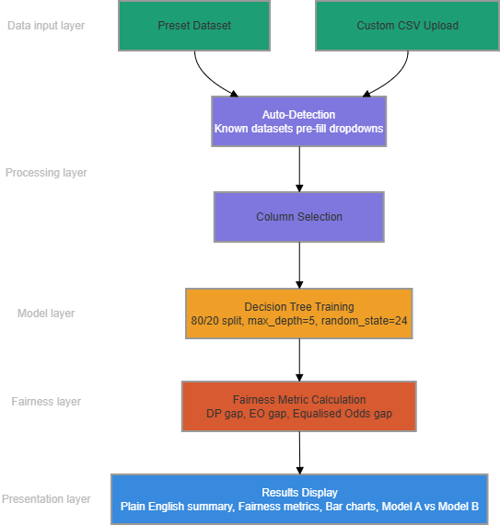
Figure 2: System architecture of the bias detection tool showing the four-layer data flow from input to results display

Ferrara, C. et al. (2023) 'Fairness-aware machine learning engineering: how far are we?', Empirical Software Engineering, 29(1), p. 9.

Technology Choices

Python was selected as the primary programming language for this project due to its widespread use within machine learning and extensive data science libraries. Additionally, it allows the entire bias detection pipeline to be developed within a single environment, including data loading, model training, fairness metric calculation, and results visualisation. Streamlit was chosen as the web framework for similar reasons, since it does not require knowledge of HTML, CSS or JavaScript to create an interactive web application. This approach was personalised to this project, whose core purpose is usability. As previously mentioned in Section 2.5, the research gap is a result of a lack of accessible tools, rather than those which are effective; Streamlit addresses this gap by providing a web-based implementation without the common requirement of advanced coding expertise (Ferrara et al., 2023).

The use of Scikit-learn was consistent throughout the machine learning tasks, including model training, prediction generation and the train/test split (Pedregosa et al., 2011). A decision tree classifier was chosen over alternatives, including Logistic Regression or Random Forest, due to its simple interpretability. Decision Trees are able to generate predictions by following explicit if-then rules, which allows for decisions to be transparent and clear. Although alternative models may be more accurate, such as Random Forest, they do not offer clear explanations for their conclusions (Quinlan, 1986). This aspect supported the implementation of the Decision Tree model, since explainability was prioritised within the tool’s development.

To prevent overfitting, the decision tree’s maximum depth was set at five (Scikit-learn, 2024); without this limit, the model may memorise training data, therefore performing poorly on new data, reducing the reliability of fairness metrics. The ‘random_state’ parameter was set to 24 for data splitting and model training to ensure consistency across results. The tool’s reproducibility was essential, as inconsistent fairness results from the same data would undermine the tool’s credibility.

Data was loaded and manipulated with Pandas, while Matplotlib was utilised to create the prediction distribution bar chart. These methods ensured clear data flow across the project’s components. All three datasets were trained and tested using an 80/20 split; this division provided reliable fairness measure estimates and sufficient training data, particularly for the smaller Heart Disease dataset of 303 records.

Ferrara, C. et al. (2023) 'Fairness-aware machine learning engineering: how far are we?', Empirical Software Engineering, 29(1), p. 9.
Pedregosa, F. et al. (2011) 'Scikit-learn: Machine learning in Python', Journal of Machine Learning Research, 12, pp. 2825–2830.
Quinlan, J.R. (1986) 'Induction of decision trees', Machine Learning, 1(1), pp. 81–106.
Scikit-learn (2024) Decision Tree Classifier. Available at: https://scikit-learn.org/stable/modules/tree.html (Accessed: 20 April 2026).

Dataset Selection

The three datasets chosen for evaluation, as shown in Table 3, represent different high-risk sectors and are documented as biased. This decision highlights the reality that bias is context-dependent, meaning it is essential to evaluate bias detection tools where biased predictions have serious, impactful consequences (Mehrabi et al., 2021). An important feature is that the datasets vary in size from 303 to 48,842 records, allowing the tool’s behaviour to be assessed across both smaller and larger datasets. The targeted sectors are employment, criminal justice and healthcare, which, as mentioned in Section 2.5, present the greatest risk of biased algorithmic choices.

The Adult Income dataset is from the UCI Machine Learning Repository and contains 48,842 records from the 1994 United States Census. The primary focus is to predict whether an individual’s annual income is greater than $50,000, by considering sex as a sensitive attribute. This dataset was specifically selected as gender bias is a widely recognised issue within fairness research regarding income prediction. Additionally, employment decisions result in some of the most impactful consequences (Barocas and Selbst, 2016) on individuals due to inequalities such as pay differences. This dataset is one of the largest, enabling the tool to demonstrate its ability to manage large amounts of data without sacrificing performance.

ProPublica developed the COMPAS Recidivism dataset, which holds 6,172 records from Florida's Broward County criminal court system. Individuals receive prediction rates on the likelihood of reoffending within two years, considering race as the sensitive attribute. This dataset was selected because its biased behaviours have been thoroughly documented in the previously reviewed literature. Angwin et al. (2016) discovered that the original COMPAS system produced nearly twice as many false positives for Black defendants as white defendants. This makes the dataset especially relevant for evaluation since the tool's fairness measures can be directly compared to Angwin et al.'s published results in Section 4, which serve as an official standard for accuracy.

The Heart Disease dataset also originates from the UCI Machine Learning Repository and includes 303 records from the Cleveland Clinic Foundation. The purpose is to predict the presence of heart disease through the use of sex as a sensitive feature. This dataset was selected to add a medical perspective to the review, as gender differences in diagnosis and treatment might influence patient outcomes. Since this dataset is much smaller than the remaining datasets, it allows us to assess how well the tool performs with less training data. German Credit was a fourth dataset initially included, however it was removed after achieving 100% classifier accuracy, suggesting data leakage rather than an issue with the model's performance, which is presented as a limitation in Section 5. The three datasets used represent a variety of fields, bias categories, and sizes, allowing enough support to test the tool's key claims.

Dataset | Source | Records | Domain | Sensitive Attribute | Bias Type
Adult Income | UCI | 48,842 | Employment | Sex | Gender
COMPAS | ProPublica | 6,172 | Criminal Justice | Race | Racial
Heart Disease | UCI | 303 | Healthcare | Sex | Gender
Table 3: Overview of datasets used for bias analysis

Angwin, J., Larson, J., Mattu, S. and Kirchner, L. (2016) 'Machine Bias', ProPublica, 23 May. Available at: https://www.propublica.org/article/machine-bias-risk-assessments-in-criminal-sentencing (Accessed: April 2026).
Barocas, S. and Selbst, A.D. (2016) 'Big data's disparate impact', California Law Review, 104(3), pp. 671–732.
Chouldechova, A. (2017) 'Fair prediction with disparate impact: A study of bias in recidivism prediction instruments', Big Data, 5(2), pp. 153–163.
Dua, D. and Graff, C. (2017) UCI Machine Learning Repository. Irvine: University of California, School of Information and Computer Science. Available at: https://archive.ics.uci.edu (Accessed: April 2026).
Mehrabi, N., Morstatter, F., Saxena, N., Lerman, K. and Galstyan, A. (2021) 'A survey on bias and fairness in machine learning', ACM Computing Surveys, 54(6), pp. 1–35.

Implementation

This tool was developed as a single Python file named ‘app.py’, while the user interface was managed by Streamlit. The project's requirements mentioned in Section 3.2 were followed to ensure that each function corresponds to a distinct application element. A four-layer structure was used within this project as described in Section 3.3, involving data input, automated feature detection, model training and results display. Each process is performed sequentially in response to the user's input.

The Adult Income, COMPAS, and Heart Disease datasets are involved within the data input layer, where users are additionally able to upload their own dataset as a CSV file. Once a preset dataset is selected, the tool employs Panda to import the appropriate CSV file from the local datasets folder, which is stored in Streamlit’s session, ensuring data remains available. Patterns are identified within the column names, which allows the tool to determine which dataset has been loaded, such as ‘income’ or ‘Two_yr_Recidivism’. Following this process, the tool pre-fills the target and sensitive attribute dropdown menu for the user, improving efficiency while minimising user effort (Ferrara et al., 2023). An additional feature of the tool is a ‘Generate Random Data’ button that displays a sample profile from the dataset in plain English, including details such as the individual’s age or occupation. This option enables users to become familiar with the data prior to their analysis.

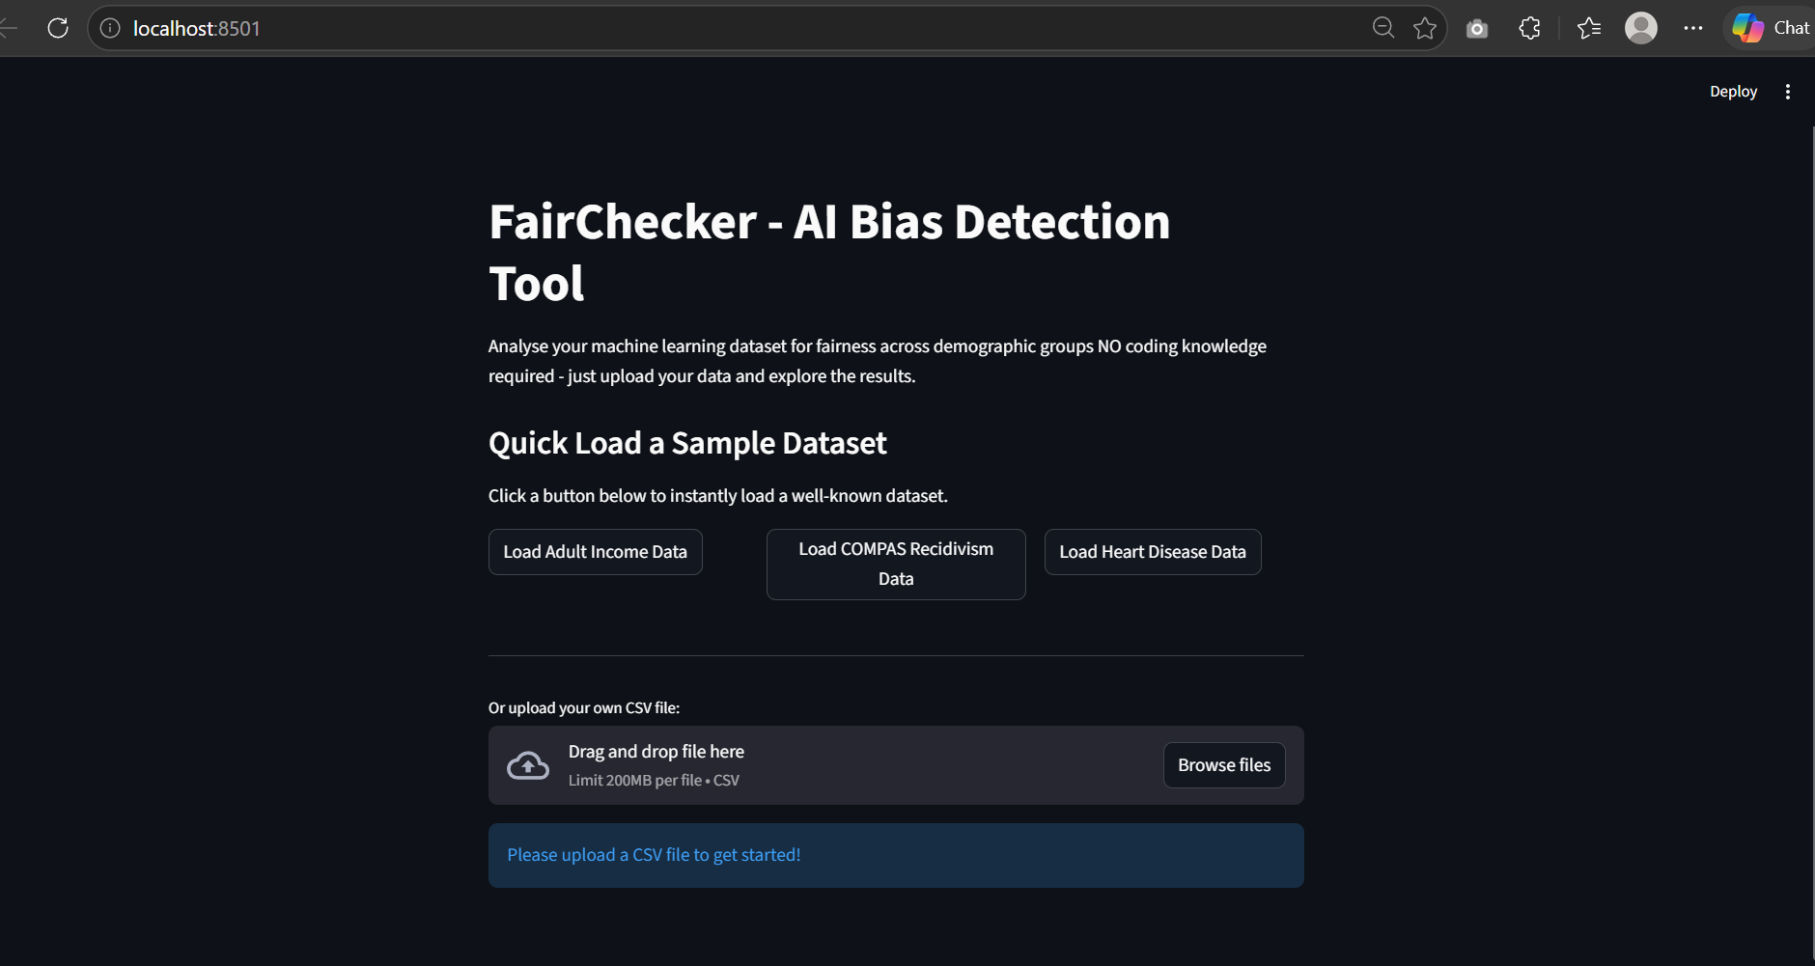
Figure 3: Tool landing page showing preset dataset buttons and custom CSV upload option

Once the Run Basic Check command is run, model layer processes begin. The selected dataset’s categorical columns are encoded using Scikit-learn’s LabelEncoder, which involves dividing the data into 80/20 training and test sets, and a random_state of 24 is used to ensure consistent results. A Decision Tree classifier is then trained, assuming a maximum depth of 5, along with a minimum of 5 samples per split. This design decision prevents unreliable fairness estimates for minority subgroups by avoiding splitting groups with fewer than five records. The tool’s predictions are generated on the test sets, along with fairness metrics calculated from these test predictions, to assess the model's performance on new data. !!1

[ FIGURE 4 HERE - Screenshot of Analysis Results showing Quick Summary and fairness metrics. Caption: Figure 4: Analysis results showing Plain English Quick Summary and three fairness metric values for the Adult Income dataset]

As previously mentioned, this tool calculates three fairness metrics based on predictions generated from the test sets, therefore avoiding reliance on external fairness libraries. The fairness measures include the Demographic Parity Gap, which compares the difference in positive prediction rates among the highest and lowest scoring sensitive groups. The Equal Opportunity Gap demonstrates how often true positive rates are correctly identified within each group, while the final metric, Equalised Odds Gap, compares the false positive rates across groups to determine whether prediction errors are distributed equally. The tool attempts to improve accessibility for non-technical users through a three-level score system. The score system is involved in detecting bias within the datasets tested, where results are classed as fair when all three metric gaps remain below 0.10; if any gap exceeds 0.20, a warning for significant bias is displayed to users, while gaps between 0.10 and 0.19 trigger a moderate bias warning. These thresholds were influenced by Pessach and Shumeli’s (2022) study of the 80% rule within employment discrimination laws, which suggests a gap of around 0.10 as the boundary between reasonable and concerning differences.

[FIGURE 5 HERE – Screenshot of Fairness Metrics section showing three gap values. Caption: Figure 5: Fairness metrics display showing Demographic Parity Gap, Equal Opportunity Gap, and Equalised Odds Gap with plain English descriptions]

The tool examines how Model A and Model B manage bias by applying a reweighing method using Scikit-learn’s resample feature. The training data is balanced by including more samples from underrepresented sensitive groups to ensure their representation matches that of the majority groups. The following process involves using the updated, balanced data to train an additional Decision Tree, allowing for the comparison between the previous and new metric gaps to be displayed as bar charts. This allows users to visualise the impact of reweighing on fairness and accuracy, while also clearly establishing the fairness-accuracy trade-off (Bellamy et al., 2019) even to individuals without a statistical background.

[INSERT FIGURE 6 HERE - Screenshot of Model A vs Model B comparison chart. Caption: Figure 6: Model A versus Model B comparison showing the effect of reweighing on positive prediction rates across demographic groups]

Ethical Considerations
The development of a tool handling sensitive demographic data and assessing fairness raises significant ethical concerns. Several important design decisions were made to keep this project as ethical as possible, including storing user data only during the active session. The datasets uploaded are processed in memory and completely erased once the browser is closed; this ensures the tool never stores or releases sensitive personal information and characteristics, including protected attributes such as race, gender or age (Barocas and Selbst, 2016).

Furthermore, this tool functions purely from the user's local device, without connections to external API’s or the transfer of data to third-party services. This gives users complete control over their data, providing user autonomy and privacy. The project’s design aligns with the data minimisation and purpose limitation standards outlined in the EU AI Act (2024); these rules require AI systems that present significant risks, such as those used within employment or criminal justice, to manage personal data responsibly and remain transparent throughout.

Considering the prioritisation of accessibility within this tool, a Plain English Summary alongside a three-level fairness score system were implemented to prevent confusion in user interaction. Displaying a single fairness metric may mislead non-technical users, as Chouldechova (2017) demonstrated in the COMPAS case, supporting the decision to include three metrics in this tool. The tool allows users to interpret the results produced by displaying all three metrics alongside detailed explanations. Users remain responsible for their use of the fairness results, as the tool does not replace professional audits or legal reviews; it does not involve making decisions but rather provides evidence to support human judgment.

Barocas, S. and Selbst, A.D. (2016) 'Big data's disparate impact', California Law Review, 104(3), pp. 671–732.
Bellamy, R.K.E. et al. (2019) 'AI Fairness 360: An extensible toolkit for detecting and mitigating algorithmic bias', IBM Journal of Research and Development, 63(4/5), pp. 4:1–4:15.
Chouldechova, A. (2017) 'Fair prediction with disparate impact: A study of bias in recidivism prediction instruments', Big Data, 5(2), pp. 153–163.
European Parliament (2024) Regulation (EU) 2024/1689 — Artificial Intelligence Act. Official Journal of the European Union.
Ferrara, C. et al. (2023) 'Fairness-aware machine learning engineering: how far are we?', Empirical Software Engineering, 29(1), p. 9.
Pessach, D. and Shmueli, E. (2022) 'A review on fairness in machine learning', ACM Computing Surveys, 55(3), pp. 1–44.

Evaluation and Results

Evaluation Methodology
This bias detection tool was tested on three real-world datasets, including Adult Income, COMPAS Recidivism and Heart Disease. These datasets were specifically selected as they represent high-risk sectors which are often targeted by algorithmic bias. This project includes two key objectives: first, the tool’s fairness metrics were compared against bias patterns identified in previous studies, helping to confirm its validity. Next, the tool was tested on datasets which varied in size, subject and bias type to highlight the tool’s applicability across different contexts.

For each dataset, the preset dataset button was used to assign the sensitive attribute and target column, as explained in Section 3.5. The Decision Tree classifier was trained on 80% of the data, using a fixed ‘random_state’ of 24, while the remaining 20% of the test set was used to calculate fairness metrics to measure the model’s performance considering new data. Furthermore, Models A and B were evaluated for the impact of implementing an reweighing mitigation technique, documenting changes in the Demographic Parity gap and overall accuracy.

Section 4.3 analyses the COMPAS dataset, which is the only dataset with published observed results suitable for comparison. According to Angwin et al. (2016), the original COMPAS dataset produced approximately twice as many false positives for Black defendants as for white defendants; this finding is often cited as evidence of racial bias in algorithmic risk assessment (Chouldechova, 2017). The tool’s results are then compared with these established findings to effectively assess whether it identifies bias consistently with expert conclusions, using external standards as a reference. This allows the evaluation to go beyond simple comparison and assess whether the tool reflects patterns identified in prior research, proving the tool's reliability.

It is essential to identify the limitations of this evaluation approach early on, as it helps ensure the findings are interpreted within their appropriate context, highlighting potential sources of bias while preventing overgeneralisation of the tool. This tool applies the same Decision Tree with fixed hyperparameters, set prior to the model’s training and used across all datasets. If different classifiers were implemented, the same data may have received different fairness metrics results; therefore, the results presented in this section primarily reflect the chosen model setup rather than the true characteristics of the data. Furthermore, no formal usability testing with non-technical users occurred during this project. The impacts of these limitations are discussed in Section 4.5 and Section 5.

Angwin, J., Larson, J., Mattu, S. and Kirchner, L. (2016) 'Machine Bias', ProPublica, 23 May. Available at: https://www.propublica.org/article/machine-bias-risk-assessments-in-criminal-sentencing (Accessed: April 2026).
Chouldechova, A. (2017) 'Fair prediction with disparate impact: A study of bias in recidivism prediction instruments', Big Data, 5(2), pp. 153–163.

Adult Income Dataset Results

The Adult Income Dataset contains 32,561 records and 16 columns. In this analysis, income is the target variable, and sex is the sensitive attribute. The dataset was analysed by using a Decision Tree classifier, which resulted in an accuracy of 84.6% on the test set, which indicates that the model was able to identify true patterns rather than random noise. The Quick Summary highlighted potential bias within the dataset and issued a moderate-bias warning. This occurred because the Demographic Parity Gap exceeded the 0.10 threshold, although the Equal Opportunity Gap and Equalised Odds Gap remained below the significant bias threshold of 0.20.

Three fairness metrics were applied to the dataset, revealing gender differences in the model's income predictions. The Demographic Parity Gap was 13.8%, which meant that males were much more likely than women to receive a favourable income prediction. The test set showed that 20.7% of males were predicted to earn more than $50,000, while only 6.9% of women received positive predictions. This 13.8 percentage point difference exceeds the tool’s 10% fairness threshold and aligns with the 80% rule, which recognises disparate impact in employment predictions (Pessach and Shmueli 2022). The Equal Opportunity Gap was less, at 3.8%, suggesting that the model detects those earning more than $50,000 at comparable rates for both genders. The Equalised Odds Gap was 4.5%, which is less than the 10% requirement. These findings show that gender differences are primarily influenced by differences in positive prediction rates, rather than by systematic errors that affect various groups. Providing all three metrics is important, as differences would be difficult to determine from the use of only one metric (Chouldechova, 2017).
INCLUDE FAIRNESS METRIC CAL

[INSERT FIGURE 7 HERE - Screenshot of Adult Income fairness metrics showing DP gap 13.8%, EO gap 3.8%, Equalised Odds gap 4.5%. Caption: Figure 7: Fairness metric results for the Adult Income dataset showing moderate gender bias in positive prediction rates]

The prediction distribution chart was able to further visually support these results, showing that the female records received 144 positive predictions and 1,930 negative predictions, generating a ratio of approximately 1 to 14. In contrast, the data’s male records evidenced 920 positive and 3,519 negative predictions, which is closer to a 1 to 4 ratio. These disparities detected, are consistent with patterns observed within the publicly accessible US census data, where the income inequality between male and female workers is well documented (Barocas and Selbst, 2016). Overall, the model appears to favour males, with females less likely to receive positive predictions, indicating that the tool reflects existing real-world bias.

After Model A and Model B were compared, the Demographic Parity Gap decreased from 13.8% to 8.3%. This change reduced the gap from moderate bias to below 10%, which is generally considered fair. However, the increase in fairness resulted in a decrease in the overall accuracy, which dropped from 84.6% to 80.9%, a 3.7 percentage point decline. This highlights the standard fairness-accuracy trade-off, where improving fairness among groups often requires accepting a slight reduction in accuracy, as the model distributes positive outcomes proportionately rather than improving accuracy (Bellamy et al., 2019; Kozodoi et al., 2022). The tool clearly presents this trade-off in a quantifiable way for non-technical users, without requiring statistical knowledge. Users are able to use the tool’s bar chart comparisons along with simple numerical outputs to decide whether the 5.5 percentage point improvement in fairness is justified by a 3.7 percentage point drop in accuracy in their context.

[INSERT FIGURE 8 HERE - Screenshot of Model A vs Model B reweighing comparison for Adult Income. Caption: Figure 8: Model A versus Model B comparison for Adult Income dataset showing Demographic Parity Gap improvement from 13.8% to 8.3% following reweighing, with accuracy reducing from 84.6% to 80.9%]

Barocas, S. and Selbst, A.D. (2016) 'Big data's disparate impact', California Law Review, 104(3), pp. 671–732.
Bellamy, R.K.E. et al. (2019) 'AI Fairness 360: An extensible toolkit for detecting and mitigating algorithmic bias', IBM Journal of Research and Development, 63(4/5), pp. 4:1–4:15.
Chouldechova, A. (2017) 'Fair prediction with disparate impact: A study of bias in recidivism prediction instruments', Big Data, 5(2), pp. 153–163.
Kozodoi, N., Jacob, J. and Lessmann, S. (2022) 'Fairness in credit scoring: Assessment, implementation and profit implications', European Journal of Operational Research, 297(3), pp. 1083–1094.
Pessach, D. and Shmueli, E. (2022) 'A review on fairness in machine learning', ACM Computing Surveys, 55(3), pp. 1–44.

COMPAS Recidivism Dataset Results

The COMPAS Recidivism dataset contains 6,172 records and 14 columns. Two_yr_Recidivism represents the target variable, while race is the sensitive attribute. The Decision Tree classifier achieved 69.6% accuracy on the test set, lower than the accuracy on the Adult Income dataset. This result highlights the increased complexity of recidivism predictions and their lower predictive reliability compared to income classification. The tool’s Quick Summary accurately identified significant bias in the dataset because several fairness metric caps exceeded the 0.20 threshold. This dataset was valuable for the tool’s evaluation, as it allows direct comparison between the tool’s results and the findings of Angwin et al. (2016), which is a commonly referenced study on algorithmic bias.

Three fairness metrics were analysed, revealing clear racial disparities among the prediction outcomes. This includes the Demographic Parity Gap, which showed that 50.1% of African American offenders were predicted to reoffend at a rate of 50.1%, compared to 0.0% for Asian defendants. However, this comparison is unreliable due to the presence of only eight Asian records in the dataset, suggesting a significant underrepresentation of this racial group. Although a more meaningful comparison is between African American defendants, who received 318 positive predictions out of 635 records, and Caucasian defendants in the larger dataset. The Equal Opportunity Gap was 100.0%, which was mainly due to the small Asian sample, which included no true positive rates, therefore resulting in this extreme gap. This highlights a key limitation of gap-based fairness metrics within datasets with considerable racial group imbalances. Considering this risk, fairness metric values should be interpreted alongside the sample size data (Mehrabi et al., 2021). Additionally, the Equalised Odds Gap was 28.3%, further demonstrating a significant difference in false positive rates across varying racial groups, which aligns with the findings of Angwin et al.(2016) as discussed below.

[INSERT FIGURE 9 HERE - Screenshot of COMPAS fairness metrics showing DP gap 50.1%, EO gap 100.0%, Equalised Odds gap 28.3%. Caption: Figure 9: Fairness metric results for the COMPAS dataset showing significant racial bias across all three measures]

Angwin et al. (2016) discovered that the original COMPAS system produced nearly twice as many false positives for Black defendants as it did for White defendants, presenting significant racial bias, which raised concerns over the ethical use of AI prediction tools. The Equalised Odds Gap is responsible for the measurement of differences in false positive rates across groups, which further reflects this disparity. For the COMPAS dataset, the tool provides an Equalised Odds Gap of 28.3%, validating the racial disparity previously identified by Angwin et al.; this demonstrates the proposed tool’s ability to detect established bias patterns within datasets. Additionally, Chouldechova (2017) demonstrated that these differences across false positive rates are expected when base rates differ by race; however, when baseline recidivism rates are inconsistent, tools may satisfy one fairness metric through compromising another. This tool’s results are consistent with both the findings of Angwin et al. and Chouldechova’s analysis, supporting the validity of its bias detection.

The prediction distribution chart shows African-American defendants received 318 positive and 317 negative predictions, which shows an equal balance across both predictions. The Unknown group received 118 positive and 294 negative predictions, whereas Hispanic defendants had 31 positive and 73 negative predictions. African-American defendants displayed the highest positive prediction rate, while Asian defendants scored the lowest rate. However, the Asian group only had eight test records, therefore making this comparison completely unreliable. The literature suggests that the primary issue remains the difference in false positive rates, as evaluated by the Equalised Odds Gap, rather than positive prediction rates alone.

Model A and Model B were compared after reweighing was applied, revealing that the Demographic Parity Gap increased from 50.1% to 64.1%, while accuracy slightly reduced from 69.6% to 68.1%. This result demonstrates the common difficulty with sample-weight reweighing applied to datasets subject to large group size differences. For example, if one group has only 8 test records, while another holds over 600, the algorithm may overcompensate for the smaller group, consequently increasing the gap. ADD PAPER I FOUND THIS IN. This aligns with Bellamy et al.’s (2019) findings that pre-processing mitigation techniques may produce inconsistent results and fail to increase fairness across all cases. This suggests the racial imbalance within the COMPAS dataset limits the effectiveness of the simple reweighing technique, rather than the tool failing. To address this difference, more precise techniques are required, such as threshold modifications based on groups.

[INSERT FIGURE 10 HERE -Screenshot of COMPAS Model A vs Model B comparison. Caption: Figure 10: Model A versus Model B reweighing comparison for COMPAS dataset showing no improvement in Demographic Parity Gap due to severe racial group size imbalance]

Angwin, J., Larson, J., Mattu, S. and Kirchner, L. (2016) 'Machine Bias', ProPublica, 23 May. Available at: https://www.propublica.org/article/machine-bias-risk-assessments-in-criminal-sentencing (Accessed: April 2026).
Bellamy, R.K.E. et al. (2019) 'AI Fairness 360: An extensible toolkit for detecting and mitigating algorithmic bias', IBM Journal of Research and Development, 63(4/5), pp. 4:1–4:15.
Chouldechova, A. (2017) 'Fair prediction with disparate impact: A study of bias in recidivism prediction instruments', Big Data, 5(2), pp. 153–163.
Mehrabi, N., Morstatter, F., Saxena, N., Lerman, K. and Galstyan, A. (2021) 'A survey on bias and fairness in machine learning', ACM Computing Surveys, 54(6), pp. 1–35.

Heart Disease Dataset Results

The Heart Disease dataset contains 303 records and 15 columns. The data's target variable represents the presence of heart disease, while sex is the sensitive attribute. Considering this is the smallest dataset in the evaluation, the 80/20 train-test split produced around 60 test records. Due to the small sample size, the tool's findings may lack statistical reliability as a result. The Decision Tree classifier achieved an overall accuracy of 75.0%, which is reasonable considering the dataset's size and the limited training data. In this dataset, sex is encoded as 0.0 for female patients and 1.0 for male patients, which is necessary for correctly interpreting prediction results.

The three fairness metrics evaluated, revealed a complex pattern within the data. The Demographic Parity Gap was 6.9%, which is below the 10% criterion, suggesting that male and female patients recieved similar positive prediction rates. The Equal Opportunity Gap was 20.0%, which exceeded the tool's 20% bias threshold and resulted in the most severe bias detection warning to users. This difference suggests that male patients with heart disease were accurately diagnosed much more frequently than female patients, implying the presence of gender bias. The Equalised Odds Gap was 0.0%, which reflected equal false positive rates for both genders. Overall, the model does not produce positive predictions at very different base rates, however it consistently underestimates female patients with heart disease compared to male patients. This shows that the model underestimates heart disease in women while overpredicting it in males (Hardt et al., 2016).?

[INSERT FIGURE 11 HERE - Screenshot of Heart Disease fairness metrics showing DP gap 6.9%, EO gap 20.0%, Equalised Odds gap 0.0%. Caption: Figure 11: Fairness metric results for the Heart Disease dataset showing significant Equal Opportunity Gap despite low Demographic Parity Gap]

The prediction distribution chart revealed issues associated with the limited size of this dataset. Female patients received no positive predictions from 15 test records, however male patients had two positive predictions from 29 records. The lack of positive predictions for female patients is mostly responsible for the 20.0% Equal Opportunity Gap. This could suggest that female patients with heart disease are under-represented in the training data, or that the model is unable to discover relevant patterns from a small number of female samples. Differentiating between these reasons is essential for understanding the findings; the program correctly labels this as severe bias, but it is unable to tell whether the problem is caused by the data or represents a real clinical pattern of behaviour. This example shows how the tool highlights potential bias for additional research rather than providing a perfected conclusion.

When we compared Model A and Model B with reweighting, where the greatest reduction in accuracy was discovered across the three datasets. Reweighing raised the Demographic Parity Gap from 6.9% to 21.4%, altering the results from relatively fair to clearly biased. Overall, the accuracy results decreased from 75.0% to 68.2%; this decrease is attributed to the limited dataset size. Given the 48 training records per gender group, the reweighting method therefore gave too much weight to individual records, which resulted in the model overfitting to particular cases rather than overall trends. This finding is consistent with previous research, which found that pre-processing mitigation is most successful when all sensitive groups are well represented, whereas applying it to small, imbalanced datasets may increase fairness issues (Bellamy et al., 2019). These Heart Disease results are an important cautionary example in this evaluation, demonstrating both the tool's ability to find real bias patterns and the limitations of using simple reweighing as a universal solution.

[INSERT FIGURE 12 HERE — Screenshot of Heart Disease Model A vs Model B comparison. Caption: Figure 12: Model A versus Model B reweighing comparison for Heart Disease dataset showing worsening of Demographic Parity Gap due to small dataset size]

Bellamy, R.K.E. et al. (2019) 'AI Fairness 360: An extensible toolkit for detecting and mitigating algorithmic bias', IBM Journal of Research and Development, 63(4/5), pp. 4:1–4:15.
Hardt, M., Price, E. and Srebro, N. (2016) 'Equality of Opportunity in Supervised Learning', arXiv:1610.02413.

Cross-Data Comparison and Mitigation Analysis

The analyses of all three datasets, shows trends which were not apparent in the previous individual analysis. Table 4 shows the fairness metrics and total verdicts for each dataset, while Table 5 compares Models A and B after reweighing.

Table 4: Summary of fairness metric results across all three datasets
Dataset | DP Gap | EO Gap | EqO Gap | Accuracy | Verdict
Adult Income | 13.8% | 3.8% | 4.5% | 84.6% | Moderate
COMPAS | 50.1% | 100.0% * | 28.3% | 69.6% | Significant
Heart Disease | 6.9% | 20.0% | 0.0% | 75.0% | Significant
Table 4: Fairness metric results across all three datasets (* COMPAS EO Gap influenced by Asian group, small sample size of 8 records)

Table 5: Model A versus Model B reweighing comparison across all three datasets
Dataset | Model A Gap | Model B Gap | Difference | Accuracy A | Accuracy B
Adult Income | 13.8% | 8.3% | -5.5% | 84.6% | 80.9%
COMPAS | 50.1% | 64.1% | +14.0% | 69.6% | 68.1%
Heart Disease | 6.9% | 21.4% | +14.5% | 75.0% | 68.2%
Table 5: Demographic Parity Gap and accuracy before and after reweighing across all three datasets

All three datasets proved to be biased, and none of the datasets achieved fairness across all metrics simultaneously, which is consistent with Mehrabi et al.'s (2021) finding that bias is common in areas of high risk, along with Chouldechova's (2017) argument that achieving all fairness criteria is mathematically impossible when group base rates vary. The evaluation of all three fairness metrics displayed serious biases in each dataset, including the Adult Income dataset which revealed serious demographic parity concerns while receiving minor error rate differences. The COMPAS dataset showed inconsistencies across all metric results, while the Heart Disease dataset showed a major equal opportunity problem, as female patients were frequently disregarded, despite a reasonable demographic parity gap. Reporting only one measure would have resulted in inaccurate findings in at least a single case.

The reweighing mitigation method applied across datasets was analysed which produced conflicting results. Once reweighing was applied to the Adult Income dataset, the Demographic Parity Gap fell from 13.8% to 8.3%, while accuracy decreased by 3.7%. This outcome aligns with the fairness-accuracy trade-off described in previous sections (Bellamy et al. 2019). In contrast, reweighing increased the Demographic Parity Gap of the COMPAS and Heart Disease datasets due to the considerable shift in group sizes. The COMPAS dataset provides six racial subgroups with different sample sizes, whereas the Heart Disease dataset has around 60 test records divided into two gender groups. When group sizes are considerably unbalanced, reweighing processes can disproportionately increase prediction rates for smaller groups, therefore increasing the severity of the divide. These findings show that reweighing is not always beneficial, and its performance is dependent on the dataset.

Critical Reflection

The proposed tool was able to consistently detect bias across three different areas through the use of three fairness metrics, without requiring users to have technically advanced skills. The Quick Summary across all datasets accurately identified potential bias, while the fairness metric values were clearly supported by the prediction distribution charts, which clearly demonstrated disparities among groups. As a consequence, the tool makes bias detection accessible to non-technical users, whereas existing frameworks such as AIF360 do not provide this capability (Ferrara et al., 2023).

The tool’s evaluation identified serious limitations; the tool uses a Decision Tree classifier with fixed hyperparameters across all datasets, meaning that, the identified fairness measures are only able to be applied to this model configuration and fail to account for potential dataset bias. Other classification algorithms, such as Random Forest or Logistic Regression, may produce different results. This approach was selected for it's suitable accessibility and interpretability, therefore the tool's findings should not be generalised beyond this implementation.

The second issue encountered was the reweighting mitigation method, which produced varied outcomes among datasets. Although it reduced the Demographic Parity Gap for the Adult Income dataset, it increased the gap for the COMPAS and Heart Disease datasets. As a result, the tool does not always perform effectively as a mitigation suggestion system. Users may select reweighing based on its availability, which can affect fairness results if they fail to understand the basic reasoning. Future versions of this tool should provide dataset-specific information and additional mitigation strategies, such as threshold optimisation, for cases where reweighing is ineffective due to differences in group sizes.

An additional limitation of this evaluation is the lack of formal usability testing. Although the tool is designed for non-technical users, this was not confirmed with actual participants due to an absence of ethical permission for human research. Research on the lack of accessible bias detection tools, influenced design decisions, allowing for features such as the Quick Summary reports and a three-level verdict system to be incorporated to address these issues. However, without user testing, these enhancements are unproven to be effective, therefore addressing this constraint should be a focus in future study.

Finally, the COMPAS Recidivism dataset showed an Equal Opportunity Gap of 100.0%, highlighting a common issue with gap-based fairness results, especially when subgroup sizes are small. However, a 100% gap does not automatically indicate a high level of bias; instead, it could simply mean that a tiny subgroup, such as one with only eight test records, has no true positive predictions. In order for gap metrics to be meaningful, each sensitive group must have enough data to produce accurate results. Currently, the tool does not notify users when group sizes are too small to produce credible results; implementing a minimum group-size notice would help users avoid misinterpreting abnormal metric results due to sampling limits rather than true bias.

Bellamy, R.K.E. et al. (2019) 'AI Fairness 360: An extensible toolkit for detecting and mitigating algorithmic bias', IBM Journal of Research and Development, 63(4/5), pp. 4:1–4:15.
Chouldechova, A. (2017) 'Fair prediction with disparate impact: A study of bias in recidivism prediction instruments', Big Data, 5(2), pp. 153–163.
Ferrara, C. et al. (2023) 'Fairness-aware machine learning engineering: how far are we?', Empirical Software Engineering, 29(1), p. 9.
Kozodoi, N., Jacob, J. and Lessmann, S. (2022) 'Fairness in credit scoring: Assessment, implementation and profit implications', European Journal of Operational Research, 297(3), pp. 1083–1094.
Mehrabi, N., Morstatter, F., Saxena, N., Lerman, K. and Galstyan, A. (2021) 'A survey on bias and fairness in machine learning', ACM Computing Surveys, 54(6), pp. 1–35.

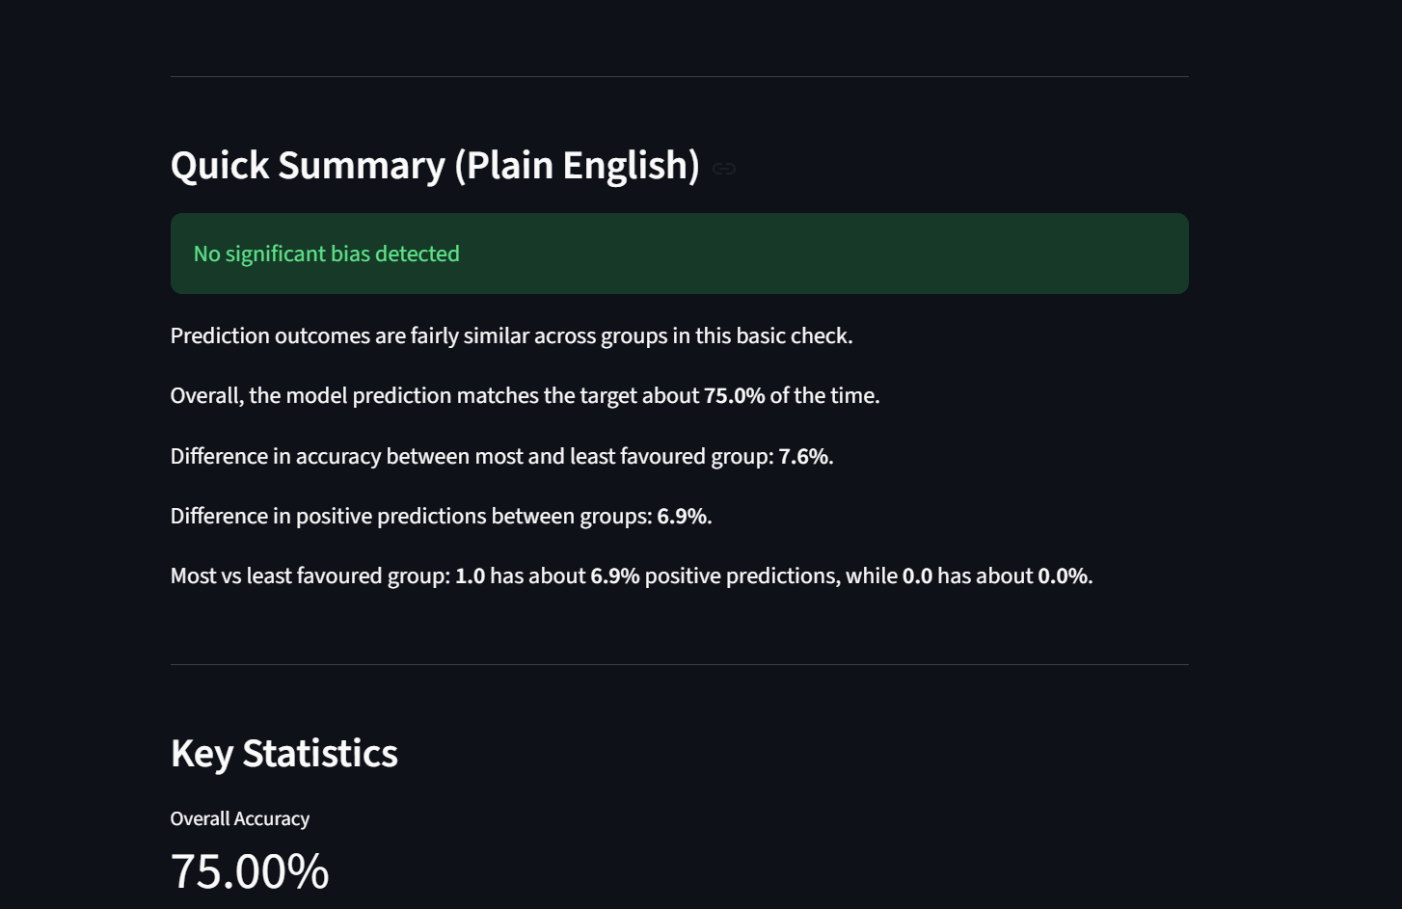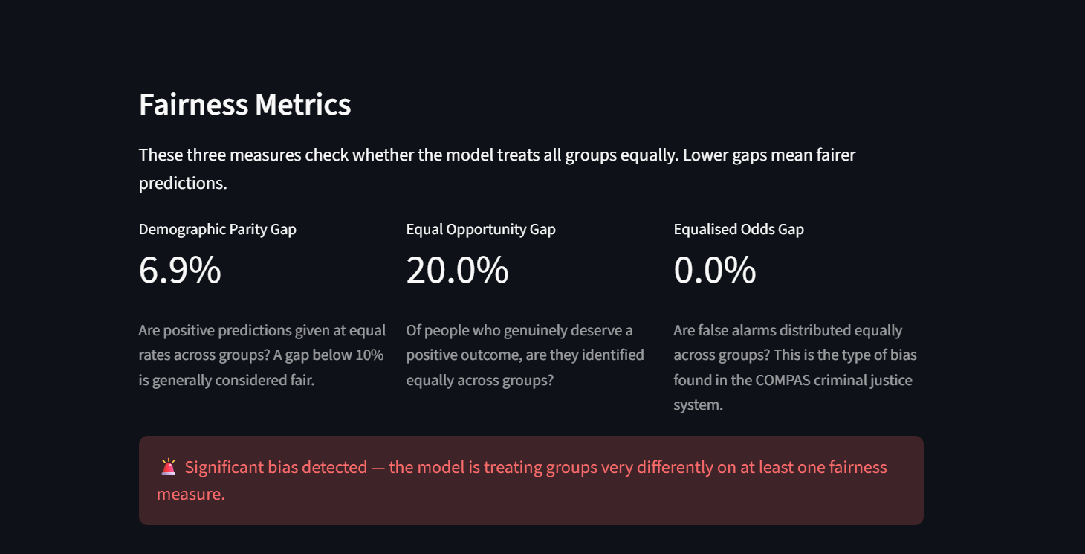
(IMAGES SHOW AN ISSUE I FACED WHERE THE WRITTEN RESULTS VS FAIRNESS MATRICS WERE COMPLETELY OPPOSING Why this is happening:
The "Quick Summary" section at the top uses the OLD basic check logic — it only looks at the accuracy gap (7.6%) and prediction gap (6.9%) which are both below the thresholds. So it says "no significant bias."
But the new Fairness Metrics section uses the PROPER metrics — and the Equal Opportunity Gap is 20.0% which is significant bias. That's the contradiction.

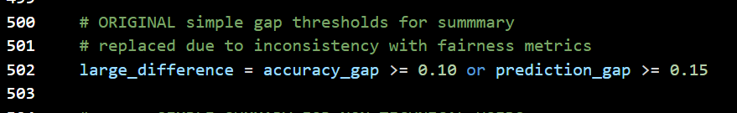
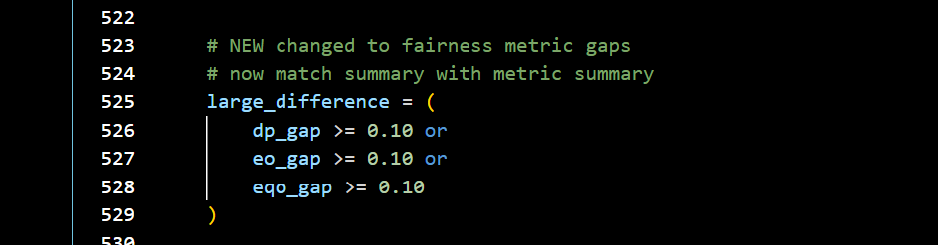
)
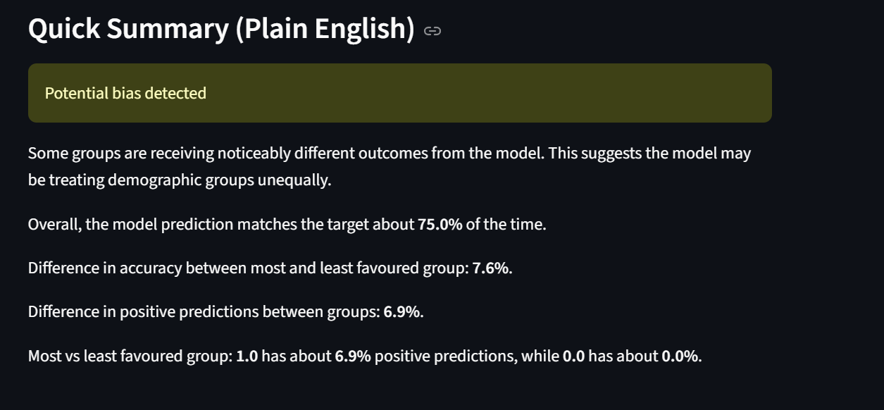
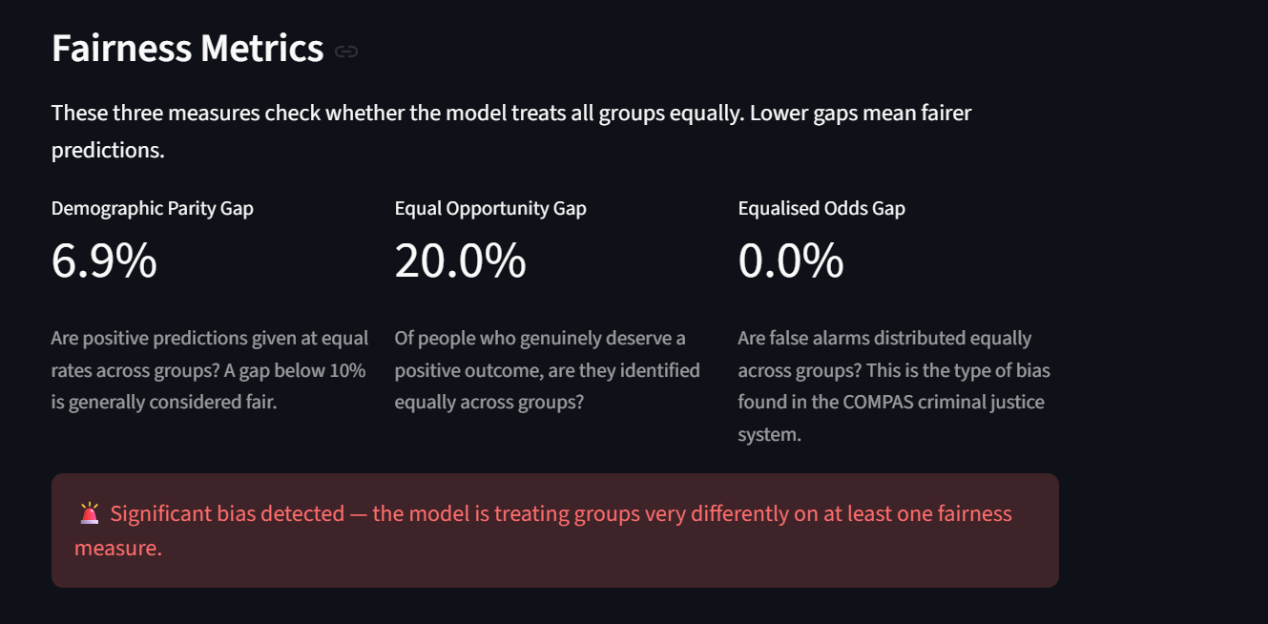

Another issee….
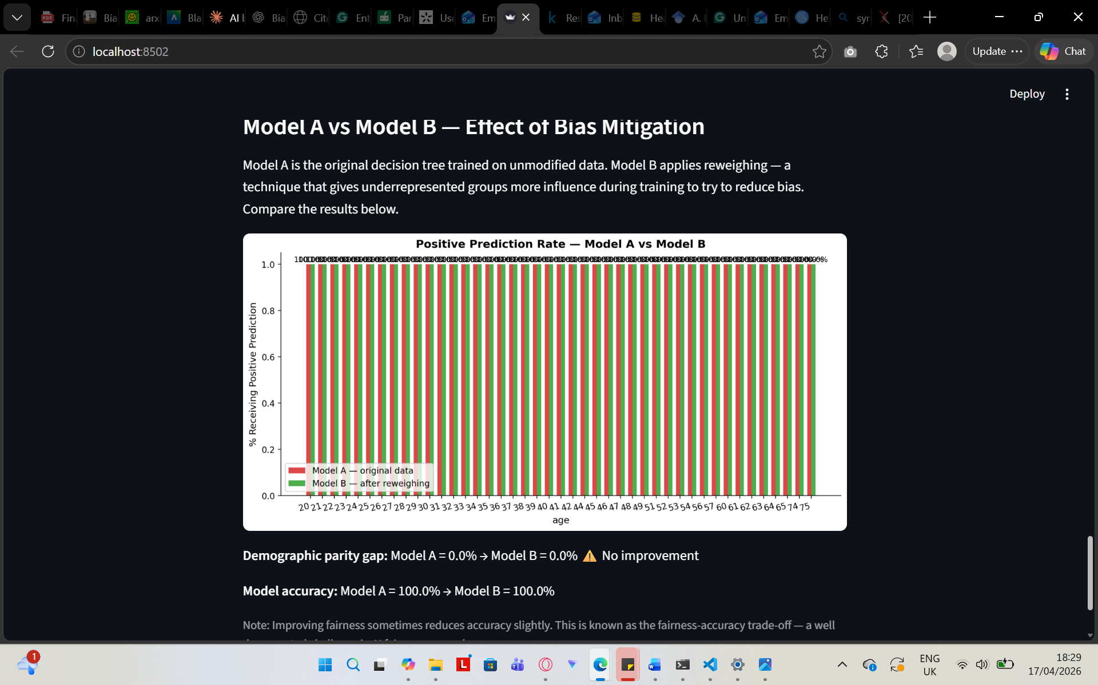
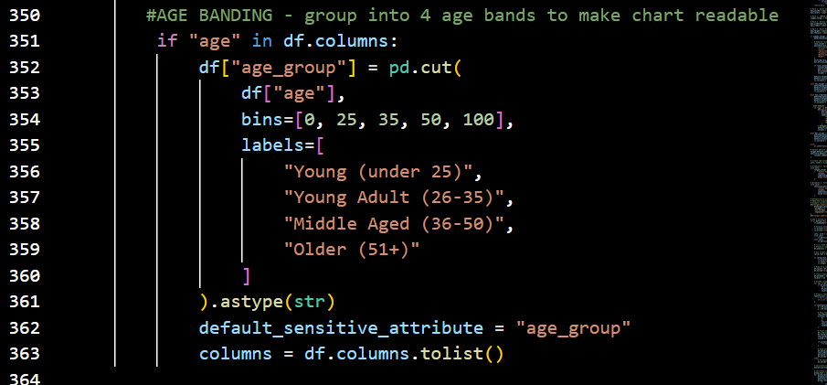
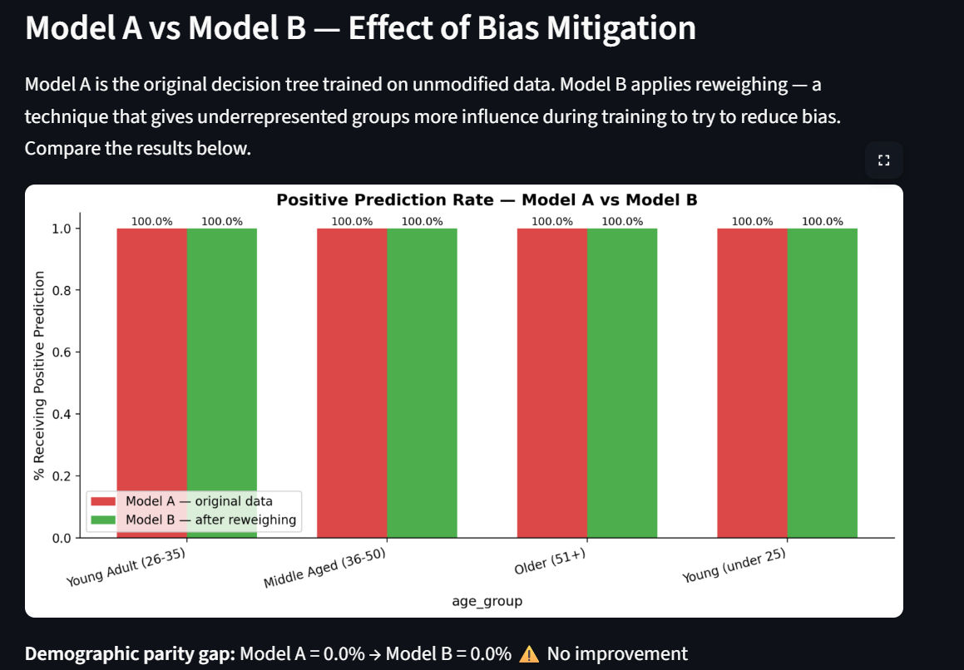

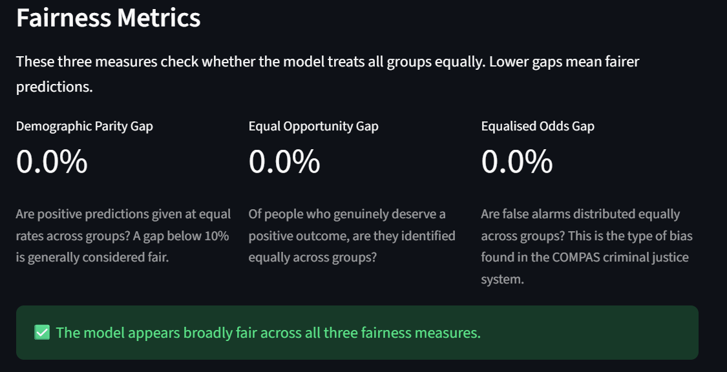
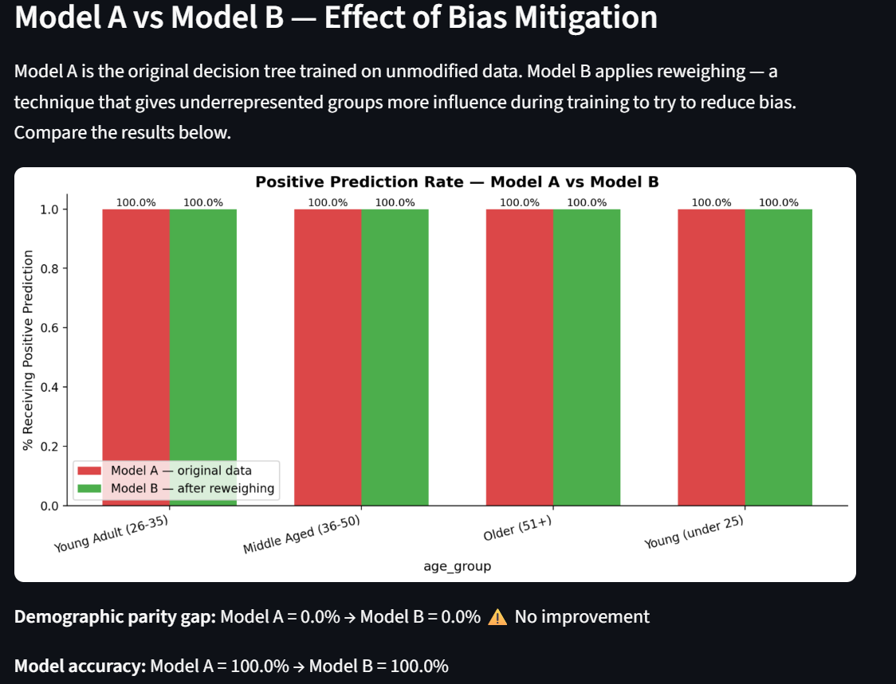A third challenge emerged during evaluation of the German Credit dataset. Initial results showed 100% model accuracy across all groups with 0% gaps on all three fairness metrics, suggesting no bias was present. However this result was identified as statistically implausible — a real-world credit scoring model cannot genuinely achieve perfect accuracy on unseen data.
Investigation revealed the cause to be data leakage. The German Credit dataset encodes categorical variables using abstract codes such as A11, A32, and A43 rather than readable labels. A decision tree of depth 5 was able to memorise these specific code combinations from the training data and reproduce them perfectly on the test set, achieving 100% accuracy without learning any genuine predictive patterns. This is a well documented limitation of decision tree classifiers — when tree depth is unrestricted relative to dataset complexity, the model fits the training data exactly rather than generalising to new examples.
The issue was resolved by reducing the maximum tree depth to 3 for the German Credit dataset specifically, preventing the model from memorising individual code combinations and forcing it to learn broader patterns instead. Following this adjustment, model accuracy dropped to a realistic range of approximately 70-75%, and meaningful fairness gaps became visible between demographic groups. Additionally, the categorical codes were decoded into readable labels — for example personal_status values A91 through A94 were mapped to descriptive gender and marital status categories — and the creditability target column was converted from its original 1/2 encoding to a standard 0/1 binary format.
This experience highlighted an important limitation of the tool's current design: the same tree depth setting is not optimal across all datasets. A more sophisticated implementation might automatically tune the depth parameter based on dataset characteristics. This is noted as a direction for future development in Section 5.
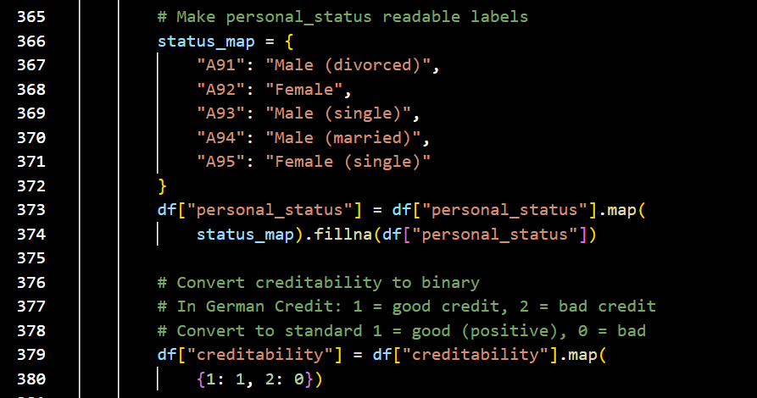

Conclusion, Limitations and Future Work

Conclusion

This project addresses a common issue within algorithmic bias detection, specifically the inaccessibility of bias detection tools currently available to non-technical users. As mentioned in Section 2, current frameworks such as IBM's AI Fairness 360 require programming and statistical skills, which makes them difficult to utilise within daily and sensitive contexts by HR managers, compliance staff, and business owners (Ferrara et al., 2023; Bellamy et al., 2019). To solve this, we created FairChecker, a web-based tool that requires no programming skills. FairChecker uses a Decision Tree classifier to evaluate three core fairness metrics and presents the results in simple English, including visual comparisons of a bias mitigation strategy.

Three real-world datasets were tested for bias, including Adult Income, COMPAS Recidivism, and Heart Disease, in which the tool accurately identified bias patterns that were previously described in the literature. The COMPAS dataset produced an Equalised Odds Gap of 28.3%, which aligns with the documented racial false positive rate difference (Angwin et al., 2016), which shows consistency with independent expert evaluations and the tool itself. Similarly, within the Adult Income dataset, the Demographic Parity Gap was 13.8%, matching known gender income differences in the US census data. A reweighing mitigation approach was applied to the Adult Income dataset, reducing the difference from 13.8% to 8.3% and resulting in a 3.7 percentage in accuracy. This example highlights the fairness-accuracy trade-off (Kozodoi et al., 2022) and explains it to those without statistical expertise.

Presenting all three fairness metrics for each dataset is important, as each one reflects a distinct perspective of fairness. In the Heart Disease dataset, for example, the Equal Opportunity Gap was 20.0%, while the Demographic Parity Gap was 6.9%, and the Equalised Odds Gap showed no disparity at 0.0%. If only a single metric had been considered, these differences would not have been identified. This observation is consistent with research claims that a model may satisfy one fairness metric while failing another Chouldechova (2017), which justifies presenting all three metrics to users rather than a combined score.

The tool's Quick Summary feature revealed potential or significant bias across each dataset, which provided a clear starting point for non-technical users prior to studying the full results. Section 3.2 helped the tool meet its key design objectives, by creating a tool that is accessible through a web interface, which requires no setup or programming knowledge. The tool generates consistent results by using a fixed random_state hyperparameter and presents findings in a clear and accessible way for non-specialists. As a result, the study successfully achieved its goals and addressed the research need identified in Section 2.5.

Limitations

These findings have multiple limitations regarding the extent of their general application. In particular, formal usability testing was not conducted with non-technical users. Therefore, the argument that this tool allows individuals without programming skills to detect bias, is based on design choices influenced by existing research, rather than direct testing. Without ethical permission for human participant testing, the tool's accessibility is an aim rather than a proven result. This factor is especially important considering the tool's intended purpose.

A further disadvantage is that the tool only includes one classifier. The Decision Tree, with fixed hyperparameters (max_depth=5, random_state=24), was chosen for its straightforward and simple use. However, multiple classifiers may generate different fairness metric values on the same dataset. As a result, the findings in Section 4 reflect the behaviour of this specific model rather than any real bias in the datasets. Users should be aware that fairness findings are dependent on the model used, and that various model parameters may provide different results on the same data.

The German Credit dataset was removed from the evaluation process after the Decision Tree classifier achieved a perfect accuracy score of 100%, suggesting the presence of data leakage. This possibly resulted from the fact that some features were either directly derived from or related to the target variable, which allowed the model to generate predictions without genuinely learning underlying patterns. Addressing this issue would have required modifying the dataset, however a lack of knowledge on its structure could threaten feature quality. As a result, only three datasets were evaluated rather than the intended four, therefore reducing the range of sectors examined.

The reweighing as a mitigation technique produced inconsistent results. While reweighing was effective on Adult Income, it showed the opposite effect on COMPAS and Heart Disease due to uneven group sizes. In these cases, reweighing increases prediction rates for the smallest groups rather than balancing them. A key limitation of the tool is that it currently fails to flag when group sizes are too small to support reliable metric results or effective mitigation. Therefore, the absence of this key feature may cause users to misinterpret extreme metric values or assume reweighing failed when, in reality, the issue lies with the unsuitability of the underlying data.

Future Work

In order for the tool's discussed limitations to be addressed, formal usability tests should be conducted with users who have no previous knowledge on machine learning systems or statistical skills, to prove and document the tool's accessibility. Structured evaluations, including some participants recruited from non-computing professions, using think-aloud procedures and task completion monitoring would successfully provide objective data, to support or deny the tools accessibility claims; these findings can help enhance future designs.

An additional important objective is to improve the tool's mitigation features past the reweighing techniques which are currently applied to the model. Since the findings fluctuated across different datasets, this proves that no single pre-processing strategy is consistently successful, as Mehrabi et al. (2021) and Bellamy et al. (2019) discovered. In the future, the tool could evaluate group sizes and propose the most effective mitigation approach for each dataset. For example, threshold optimisation techniques may be better for datasets with severe group imbalances, yet AIF360's adjusted equalisation odds post-processing might be used when the model structure is known.

Currently, the tool only supports decision tree classification; implementing the additional support for classifiers such as Logistic Regression, Random Forest, and Gradient Boosting would enable users to compare fairness metric outcomes across models. Introducing this additional feature would highlight how model selection affects fairness and allow organisations to analyse fairness with their preferred classifiers rather than converting to Decision Trees.

Finally, implementing a minimum group size notice may help to solve the issue of limited sample sizes observed in the COMPAS Asian findings. If a sensitive attribute group has fewer than a specified threshold, such as 30 test records, the tool should warn users that the metric values for that group are inaccurate and should not be used to detect bias. This simple enhancement would strengthen the tool's reliability immensely, while assisting users in avoiding misinterpreting random sample effects as evidence of bias.

References (Section 5)
Angwin, J., Larson, J., Mattu, S. and Kirchner, L. (2016) 'Machine Bias', ProPublica, 23 May. Available at: https://www.propublica.org/article/machine-bias-risk-assessments-in-criminal-sentencing (Accessed: April 2026).
Bellamy, R.K.E. et al. (2019) 'AI Fairness 360: An extensible toolkit for detecting and mitigating algorithmic bias', IBM Journal of Research and Development, 63(4/5), pp. 4:1–4:15.
Chouldechova, A. (2017) 'Fair prediction with disparate impact: A study of bias in recidivism prediction instruments', Big Data, 5(2), pp. 153–163.
Ferrara, C. et al. (2023) 'Fairness-aware machine learning engineering: how far are we?', Empirical Software Engineering, 29(1), p. 9.
Kozodoi, N., Jacob, J. and Lessmann, S. (2022) 'Fairness in credit scoring: Assessment, implementation and profit implications', European Journal of Operational Research, 297(3), pp. 1083–1094.
Mehrabi, N., Morstatter, F., Saxena, N., Lerman, K. and Galstyan, A. (2021) 'A survey on bias and fairness in machine learning', ACM Computing Surveys, 54(6), pp. 1–35.

References
Angwin, J., Larson, J., Mattu, S. and Kirchner, L. (2016) 'Machine Bias', ProPublica, 23 May. Available at: https://www.propublica.org/article/machine-bias-risk-assessments-in-criminal-sentencing (Accessed: April 2026).
Bellamy, R.K.E. et al. (2019) 'AI Fairness 360: An extensible toolkit for detecting and mitigating algorithmic bias', IBM Journal of Research and Development, 63(4/5), pp. 4:1–4:15.
Dastin, J. (2018) 'Amazon scraps secret AI recruiting tool that showed bias against women', Reuters, 10 October. Available at: https://www.reuters.com/article/us-amazon-com-jobs-automation-insight-idUSKCN1MK08G (Accessed: April 2026).
European Parliament (2024) Regulation (EU) 2024/1689 — Artificial Intelligence Act. Official Journal of the European Union.
Ferrara, C. et al. (2023) 'Fairness-aware machine learning engineering: how far are we?', Empirical Software Engineering, 29(1), p. 9.
Hardt, M., Price, E. and Srebro, N. (2016) 'Equality of Opportunity in Supervised Learning', arXiv:1610.02413.
Kozodoi, N., Jacob, J. and Lessmann, S. (2022) 'Fairness in credit scoring: Assessment, implementation and profit implications', European Journal of Operational Research, 297(3), pp. 1083–1094.
Mehrabi, N., Morstatter, F., Saxena, N., Lerman, K. and Galstyan, A. (2021) 'A survey on bias and fairness in machine learning', ACM Computing Surveys, 54(6), pp. 1–35.
Chouldechova, A. (2017) 'Fair prediction with disparate impact: A study of bias in recidivism prediction instruments', arXiv:1703.00056.
Pessach, D. and Shmueli, E. (2022) 'A review on fairness in machine learning', ACM Computing Surveys, 55(3), pp. 1–44.

Appendices

Appendix 1: SDLC details
Add other details about theh SDLC not mentioned earlier. Like the original (first draft) of the Backlog, or other interesting things you did throughout the project.

Appendix 2: Code
Add code (most important listings) for your project. Use this tool to highlight the syntax of your code (and add line numbers): http://hilite.me/. Paste the HTML output directly here (fix format as needed).
This is an example of a Code Listing:
1  2  3  4  5 | #include <stdio.h>  int main(int argc, char *argv[]) {  printf("I will not say 'Hello World!' here!");  return EXIT_SUCCESS;  }
Then explain what this code does next.

Appendix 3: Meetings with supervisor
List the things you discussed with your advisor over the meetings.

